**PULSE MONITORING SYSTEM**

|  |  |
| --- | --- |
| **Batch details** | |
| **Roll Number** | **Name** |
| 20ECR071 | KARTEESWAR K P |
| 20ECR072 | KARTHI P |
| 20ECR073 | KARTHIGA K |

**OBJECTIVE**

Here we have explained a Pulse monitoring system using a pulse sensor and Instrumentation Amplifier which is a differential which provide a large amount of gain for very low level signals. Here the pulse is detected using pulse sensor and the pulse signal is converted to large electronic signal by the amplifier for the clear observability of pulse signal.The concept of this pulse monitoring system is quite simple and based on working of instrumentation amplifier.

**HARDWARE REQUIREMENT**

|  |  |  |  |
| --- | --- | --- | --- |
| **S. No.** | **Component** | **Range** | **Quantity** |
| 1. | IC 741 |  | 3 |
| 2. | Resistor | 5K | 4 |
| 3. | Resistor | 10K | 4 |
| 4. | Pulse Sensor |  | 1 |
| 5. | Dual Supply |  |  |
| 6. | CRO |  |  |

**SOFTWARE REQUIREMENT**

* PROTEUS 8 PROFESSIONAL

**CIRCUIT DIAGRAM**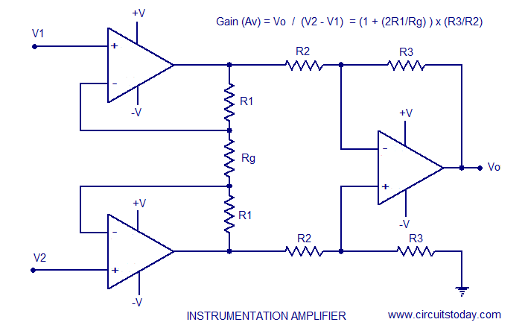

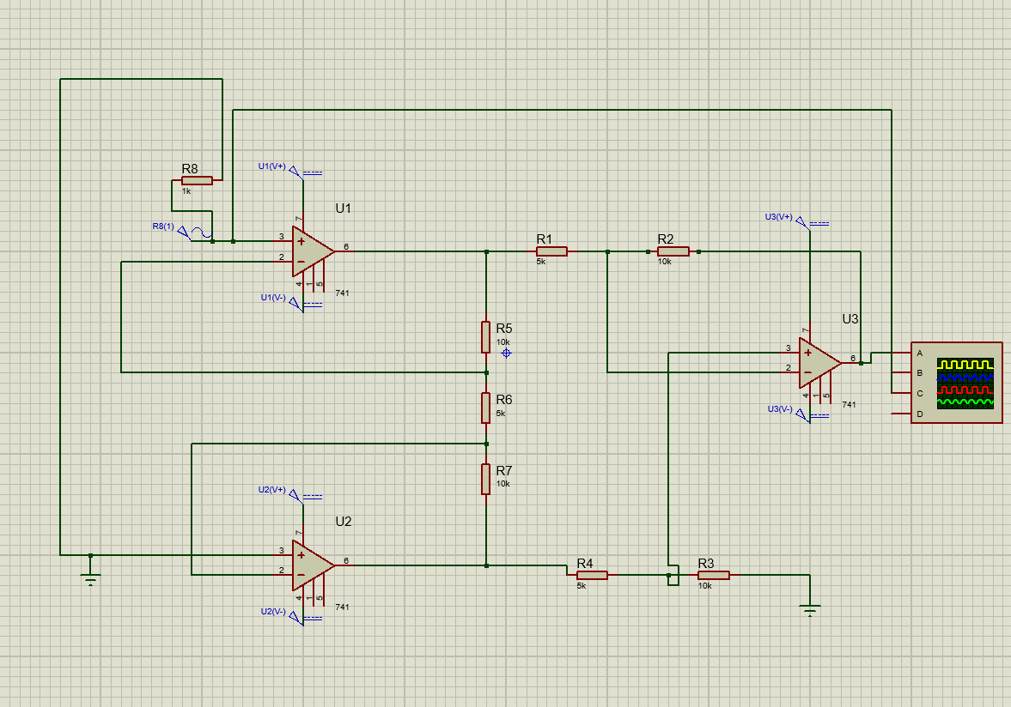

* PROTEUS 8 PROFESSIONAL
* Here the IC741 is placed in three different regions, The values of the resistors connected in the circuit will be equal.
* Except for the resistor R gain.
* At point 1 in the circuit, the voltage will be considered as V1.
* Similarly, at point 2, the voltage will be considered equal to V 2.
* The potential drop generated at the R gainis the difference between the voltages V 1and V 2.
* Because of this reason the current flow through that point that is through R gain. This indicates that there is no current flow is observed through the feedback.
* Then this results in the same amount of the current flow through resistors that are connected above and below in the circuit.
* The output pin is connected to cro to display the output and dual power supply is given.

**WORKING PRINCIPLE**

* The amplifier gets the input pulse signal using the pulse sensor. Three resistors R1, R2, and R3 are used and at the output is delivered through the difference amplifier and Vout is considered as the amplification output of the input signals.
* As the two operational amplifiers placed at the input stage draws no amount of current, the voltage drop is in linear proportion to the voltage variation between input voltages.
* This develops current which flows through the resistors and the developed voltage is supplied as input to the [differential amplifier](https://www.watelectrical.com/rotary-variable-differential-transformer-rvdt-theory/).
* Here, Rg is the external resistor that is placed in between the IC pins.
* When the pins are not connected, then amplifier gain will be one, but with different resistors, various values of gains can be obtained.
* The current flowing through Rg and R1 will be preferably similar because the current at the input stage of the operational amplifier is null.
* The output is displayed using CRO(Cathode Ray Oscilloscope).

**OUTPUT**

STEP 1:

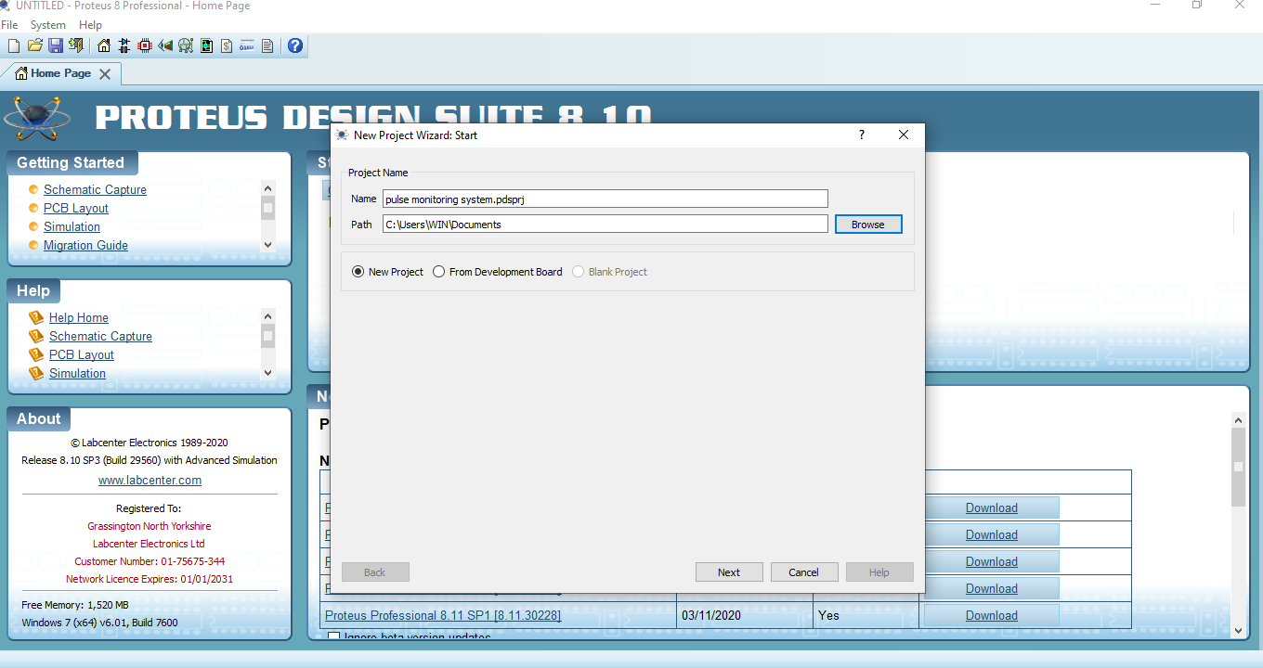

STEP 2:

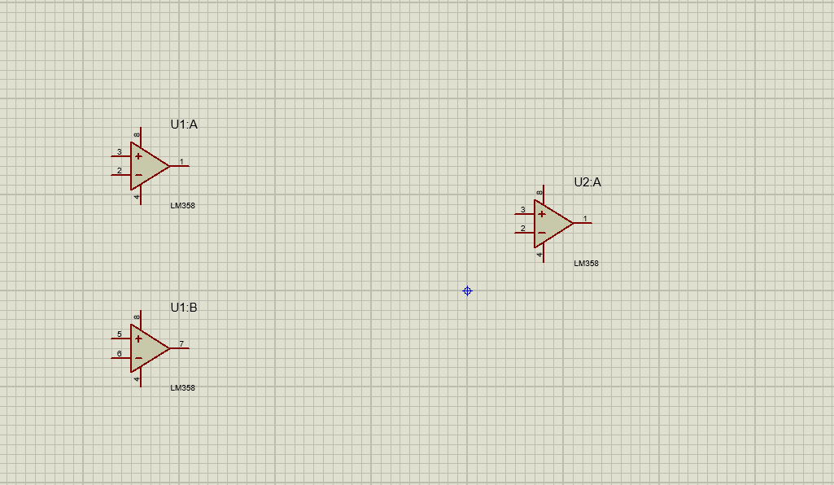

STEP 3:

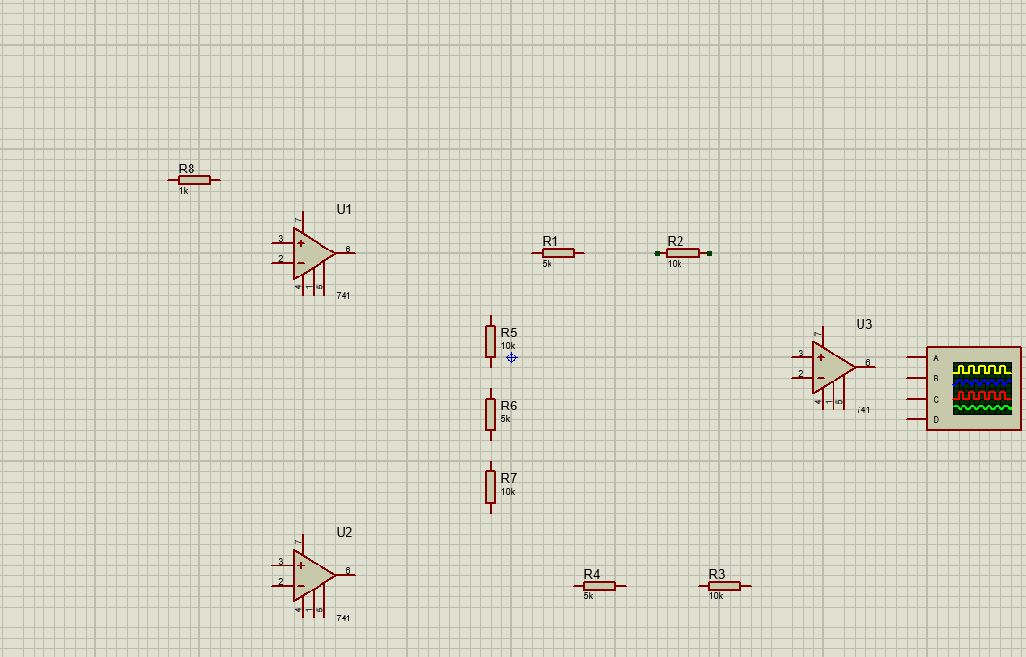

STEP 4:



STEP 5:

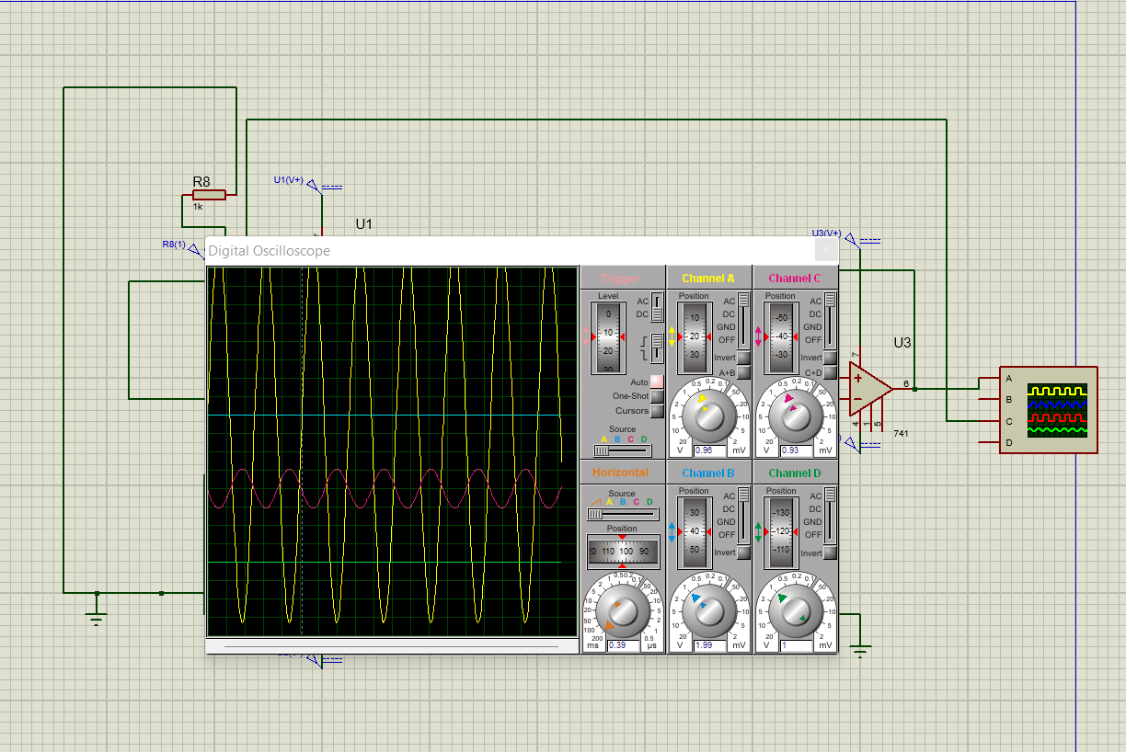

STEP 6:

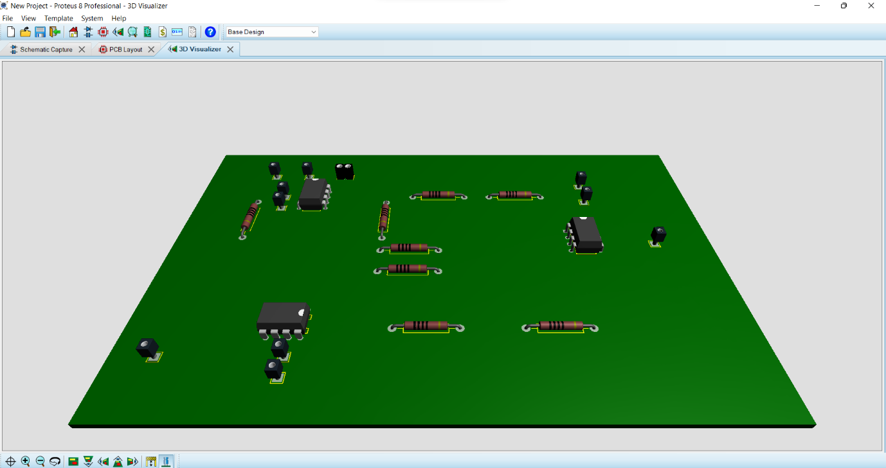

* Breadboard testing
* PCB testing

**CONCLUSION**

The pulse monitoring system is designed based on the instrumentation amplifier.Using this amplifier the pulse signal is converted to large electronic signal.The pulse monitoring system is used to get the clear visibility and observance of pulse signals.